

P.O Box 71150, Nigeria

45 Oduduwa Way, GRA Ikeja, Lagos Nigeria.

Email:

**SALES SHEET**

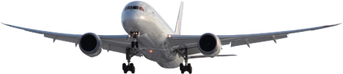

**BUSINESS TRAVEL MANAGEMENT**

**CAR TRANSFER**



**01**



Airport transfers are pre-booked methods of transport for picking up travelers from an airport and dropping them off at their chosen destination, whether it be accommodation, cruise port, or another local point of interest, for a set price.

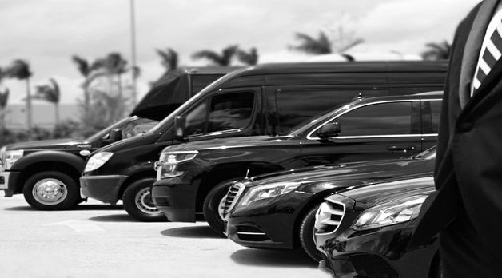

**CAR TRANSFER**

BTM has an extensive range of products and services, which may be specifically tailored to suit each individual client’s requirements. Included in our bouquet of services are the BTM Nigeria Airport car transfer services.

BTM is in partnership with notable internationally known and local suppliers reliable enough to provide globally acceptable car transfer service for our clients.

Our vehicle ranges from Sedan, SUV, Luxury SUVs, shuttle bus, secure escort, Limo services, etc. to the BTM worldwide network through our partners, this service can also be extended to travelers traveling to other BTM Partner countries.

BTM Nigeria airport transfers include options such as shared shuttles, private cars, and mini-busses, catering to a wide range of groups from small family holidays to large group getaways.



**02**



**03**



**Standard Pricing Template:**

**Note: all fees are payable in Naira or USD.**

**ACTION**

**CAR TRANSFER**

**CAR TRANSFER**

**CAR TRANSFER**

**SERVICE DESCRIPTION**

**TRAVEL SERVICES FEATURES**

**Booking Charge**

**Booking Charge**

**CHARGES**

**$15.00/ ₦11,550**

**$30.00/ ₦23,100**

**SERVICE DESCRIPTION**

**Travel service**

**Car Hire Booking/Vehicle Transfer**

**Specialized Car Bookings**



P.O Box 71150, Nigeria

45 Oduduwa Way, GRA Ikeja, Lagos Nigeria.

Email: [bidresponse@btmlimited.net](mailto:bidresponse@btmlimited.net)

**BE MANAGED BY THE BEST.**